ECET 230 Practical Final

Name: Loren Olsen

Please complete this document and include a copy in your project. Estimate your mark in each section. Save a copy with all the project files to a directory called YourFullName230Exam. Include all visual studio or unity project code. Include firmware if you made any preapproved changes. ZIP this directory and put it in D2L drop box. Only ZIP files will be excepted.

1. In this section describe your project in detail and include screen shots. Describe the most challenging part of your project. (__5__/5marks)

The most challenging part of the project for me was creating a nice UI with XAML.

Creating new RFID function on the arduino to only capture and send out the RFID Tag number. The RFID tags used have 1k of data that can be used, but for this project we only read the UID.

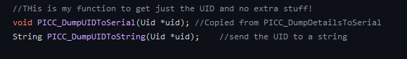

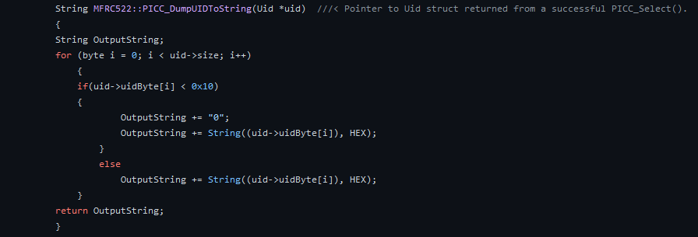

1. List links for the reference material that you found useful for your project. Comment all code clearly and include links and attributions for any code that you learned about from another source. (_5___/5marks)

The RFID reader library for Arduino :

<https://github.com/miguelbalboa/rfid>

DispatcherTimer Class:

<https://docs.microsoft.com/en-us/dotnet/api/system.windows.threading.dispatchertimer?view=windowsdesktop-6.0>

TimeSpan Struct:

https://docs.microsoft.com/en-us/dotnet/api/system.timespan?view=net-6.0

1. Intuitive well designed Graphical User Interface. (_7___/10marks)

1. Clear display of all data and controls. Properly formatted numerical data. Data and controls clearly labeled. (_5___/5marks)
2. Useful serial input and output. Document below how you used the protocol. Debugging data and count of lost packets can be seen and also hidden. Serial protocol pre-approved and properly document. Checksum used correctly to verify data. (_7___/10marks)

1. Fully prepare for demo. (_5___/5marks)
   1. Complete this document
   2. Estimate your mark in each section
   3. Charge battery if applicable
   4. Compile and test EXE
   5. ZIP directory of all project file and this doc file
2. Wire your own hardware and wiring must be good quality and safe. Make sure wires cannot be shorted. Shown clearly in demo video. (_4___/5marks)
3. Demo progress each week. (__5__/5marks)
4. Understand all parts of your project and can answer technical questions successfully. (__5__/5marks)
5. Use appropriate OOP style. Use appropriate Event driven programing. Define your classes when appropriate. Explain below how and why you used OOP style, events, classes (_6___/10marks)

I’ve created a new Rider class that contains data of each rider associated with the RFID tag UID.

1. Bug free code. (__7__/10marks)
2. Impressive demo video that you can be proud. Clear, concise, and complete. (____/5marks)
3. Make a project that highlights your programming skills. Add advanced features that require you to expand your skills. (_8___/10marks)

The classes and objects of C# programming is a difficult concept for me. The interactions between my main program and objects continues to be an issue with properly implemented code. The challenge of comparing objects of differing classes and structures, such as, comparing a DateTime to a TimeSpan was an excellent challenge for me.